

**Western Australian Certificate of Education**

**ATAR course examination, 2019**

**Question/Answer Booklet**

12 PHYSICS

Name

**Test 3 - Electromagnetism**

|  |  |  |  |  |  |  |  |  |  |  |
| --- | --- | --- | --- | --- | --- | --- | --- | --- | --- | --- |
| Student Number: In figures |  |  |  |  |  |  |  |  |  |  |

**Mark: $\frac{}{\text{40}}$**  In words

#### Time allowed for this paper

Reading time before commencing work: five minutes

Working time for paper: seventy minutes

**Materials required/recommended for this paper**

To be provided by the supervisor

This Question/Answer Booklet

Formulae and Data Booklet

***To be provided by the candidate***

Standard items: pens, (blue/black preferred), pencils (including coloured), sharpener, correction fluid/tape, eraser, ruler, highlighters

Special items: non-programmable calculators satisfying the conditions set by the School Curriculum and Standards Authority for this course

**Important note to candidates**

No other items may be taken into the examination room. It is your responsibility to ensure that you do not have any unauthorised notes or other items of a non-personal nature in the examination room. If you have any unauthorised material with you, hand it to the supervisor before reading any further.

**Structure of this paper**

|  |  |  |  |  |  |
| --- | --- | --- | --- | --- | --- |
| Section | Number of questions available | Number of questions to be answered | Suggested working time  (minutes) | Marks available | Percentage of exam |
| Section One:  Short Answers | - | - | - |  |  |
| Section Two:  Problem-solving | 11 | 11 | 70 | 55 | 100 |
| Section Three:  Comprehension | - | - | - | - | - |
|  |  |  |  | **Total** | 100 |

**Instructions to candidates**

1. The rules for the conduct of examinations at Holy Cross College are detailed in the College Examination Policy*.* Sitting this examination implies that you agree to abide by these rules.

2. Write your answers in this Question/Answer Booklet.

3. Working or reasoning should be clearly shown when calculating or estimating answers.

4. You must be careful to confine your responses to the specific questions asked and to follow any instructions that are specific to a particular question.

5. Spare pages are included at the end of this booklet. They can be used for planning your

responses and/or as additional space if required to continue an answer.

• Planning: If you use the spare pages for planning, indicate this clearly at the top of the page.

• Continuing an answer: If you need to use the space to continue an answer, indicate in the original answer space where the answer is continued, i.e. give the page number. Fill in the number of the question(s) that you are continuing to answer at the top of the page.

6. Answers to questions involving calculations should be ***evaluated and given in decimal***

***form*.** It is suggested that you quote all answers to ***three significant figures***, with the

exception of questions for which estimates are required. Despite an incorrect final result, credit may be obtained for method and working, providing these are ***clearly and legibly set out***.

7. Questions containing the instruction "estimate" may give insufficient numerical data for their solution. Students should provide appropriate figures to enable an approximate solution to be obtained. Give final answers to a maximum of two significant figures and include appropriate units where applicable.

8. Note that when an answer is a vector quantity, it must be given with magnitude and direction.

9. In all calculations, units must be consistent throughout your working.

1. Two current-carrying conductors were placed close together as shown below. What is the effect of the two fields on each other? Circle the correct response. (1 mark)

Attraction Repulsion No effect

  

2. In the diagram opposite, RS is free to move. How will RS move if the switch is closed?

(a) Circle the correct response. (1 mark)

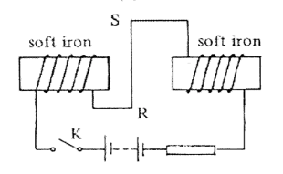

A rotate

B into the paper

C out of the paper

D downward

E upward

(b) Explain your choice. Annotate the diagram if this will help to explain your choice.

(3 marks)

3. Two point electric charges are separated by a distance ***r*** and experience a repulsive force of magnitude ***F***. If the distance between them is reduced to one-third of its previous value and one of the charges is now doubled, calculate the magnitude of the new force, in terms of ***F***.

(3 marks)

4. Which line, **A** to **D**, in the table correctly describes the trajectory of charged particles which enter separately, at right angles, a uniform electric field and a uniform magnetic field?

(1 mark)

|  |  |  |
| --- | --- | --- |
|  | **uniform electric field** | **uniform magnetic field** |
| **A** | parabolic | circular |
| **B** | circular | parabolic |
| **C** | circular | circular |
| **D** | parabolic | parabolic |

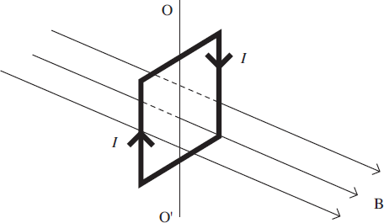

5. The diagram shows a vertical square coil whose plane is at right angles to a horizontal uniform magnetic field ***B***. A current ***I*** is passed through the coil, which is free to rotate about a vertical axis OO'.

Which one of the following statements is correct? (1 mark)

**A**      The forces on the two vertical sides of the coil are equal and opposite.

**B**      A couple acts on the coil.

**C**      No forces act on the horizontal sides of the coil.

**D**      If the coil is turned through a small angle about OO' and released, it will remain in position.

6. Which one of the following statements is correct? (1 mark)

The force between two charged particles:

**A**        is always attractive

**B**        can be measured in C2 F–1 m–1

**C**        is directly proportional to the distance between them

**D**        is independent of the magnitude of the charges

7. (a)     The equation *F* = *Bqv* may be used to calculate magnetic forces on moving charges.

State the condition under which this equation applies. (1 mark)

(b)     The figure belowshows the path followed by a stream of identical positively-charged ions, all with the same kinetic energy, as they pass through the region between two charged plates. Initially the ions are travelling horizontally and they are then deflected downwards by the electric field between the plates.

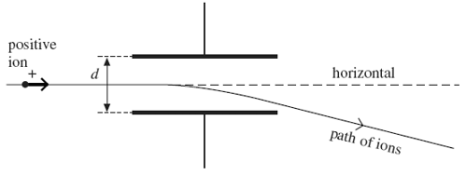

While the electric field is still applied, the path of the ions may be restored to the horizontal, so that they have no overall deflection, by applying a magnetic field over the same region as the electric field. The magnetic field must be of suitable strength and has to be applied in a particular direction.

(i)      Draw on the diagram the direction in which the magnetic field should be applied. (1 mark)

(ii)     Explain why the ions have no overall deflection when a magnetic field of the required strength has been applied. (2 marks)

(iii)     A stream of ions passes between the plates at a velocity of 1.70 x 105 ms–1. The separation ***d***of the plates is 65.0 mm and the potential difference across them is 48.0 V. Calculate the value of magnetic field strength ***B***required so that there is no overall deflection of the ions, stating an appropriate unit. (4 marks)

(c)     Explain what would happen to ions with a velocity higher than 1.70 x 105 ms–1 when they pass between the plates at a time when the conditions in part (b)(iii) have been established. (2 marks)

8. The rectangular coil shown below is to be used in a small electric motor in a toy. The coil has 100 turns of wire and each turn is rectangular with sided 0.0400 m and 0.0200 m as shown. The magnetic flux density is constant through the coil at 0.0600 T.

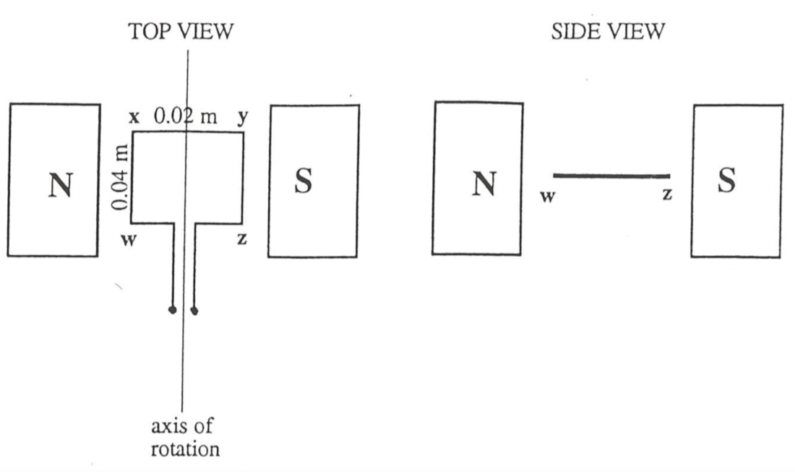

The force on the side WX of the coil is 0.0500 N in an upward direction perpendicular to WX (that is, out of the page towards you in the TOP VIEW of the coil).

(a) Indicate on the diagram the direction of the current in the side WX and the side ZY.

(1 mark)

(b) Calculate the magnitude of the current in the coil. (2 marks)

(c) Calculate the value of the maximum torque on the coil. (2 marks)

(d) There are two positions of the coil during its motion at which the toque on the coil is zero. On the ***SIDE VIEW diagram***, draw of one of these positions. (1 mark)

9. Two 2.00m conductor rods are placed one above the other as shown.

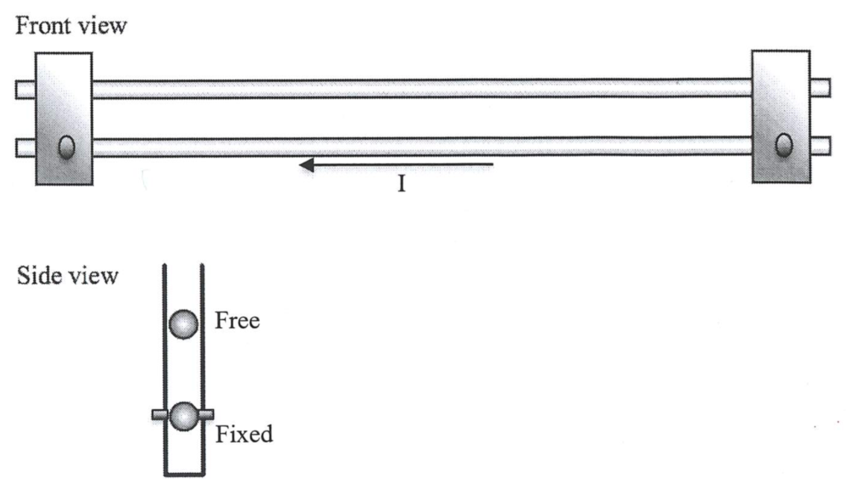

The bottom conductor is held in place by brackets and the top one is free to move up and down. Each conductor has a mass of 0.0100 kg and a current of 20.0 A moves through the bottom conductor right to left as shown in the front view above.

(a) On the front view diagram, sketch the direction of current that must flow in order for the top rod to levitate (remain in static equilibrium). (1 mark)

(b) Calculate the strength of the magnetic field produced by the bottom rod at a distance of 4.00 mm above itself. (3 marks)

(c) Calculate the current flowing in the top rod that is necessary to suspend it 4.00 mm above the bottom rod. (3 marks)

10. A beam of electrons having energies between 10 and 100 keV passes through a slit into an evacuated chamber as shown. A magnetic field makes the electrons move in a semi-circle and those with a particular velocity hit the wall at point P.

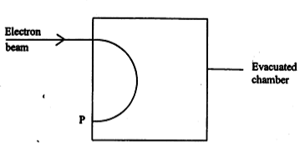

(a) Indicate on the diagram the direction of the magnetic field that would result in the electron following this path. (1 mark)

(b) Explain why the charged particles move in a circular motion in the direction of P.

(2 marks)

(c) Sketch on the diagram the path taken by an electron with a higher velocity. (1 mark)

(d) Sketch on the diagram the path of a proton when fired with the same velocity into the same evacuated chamber. (2 marks)